Mini Project – 2 A Web Based Business Model

**PROJECT NAME**

#### BLOGSITE

***2 A Web Based Business Model***

***(SEMESTER V)***

***submitted in***

***partial fulfillment of requirement for the award of degree of***

**Bachelor of Engineering**

**in**

**Information Technology**

***By***

**Hodekar Abdul Ahad Parwez (T-20-0299)**

**Gawas Shriniket Kishor (T-20-0352)**

***Guided by***

**Prof. Amar Palwankar**

**Department of Information Technology**

Finolex Academy of Management and Technology, Ratnagiri



**ACADEMIC YEAR 2022-23**

**Declaration**

We, hereby declare that, the Mini Project titled **“ BLOGSITE ”** submitted herein has been carried out by us in the Department of Information Technology at Finolex Academy of Management and Technology, Ratnagiri.

**Name of the students**:-

1. Hodekar Abdul Ahad Parwez (T-20-0299)

2. Gawas Shriniket Kishor (T-20-0352)

Date:1/11/2022

**Certificate**

The Mini Project titled “**Blogsite”** is submitted by “ Hodekar Abdul Ahad Parwez”, “Gawas Shriniket Kishor**”** in the completion of SE Bachelor in Information Technology, has been carried out under my supervision at the Department of Information Technology at Finolex Academy of Management and Technology, Ratnagiri .The work is comprehensive, complete and fit for evaluation.

**Prof. Amar R Palwankar**

Assistant Professor,

Department of Information Technology, FAMT, Ratnagiri

**INDEX**

|  |  |
| --- | --- |
| **CONTENT** | **Page No** |
| **CHAPTER 1 : INTRODUCTION** | 5 |
| **CHAPTER 2 : LITERATURE REVIEW** | 6 |
| **CHAPTER 3 : SOFTWARE AND HARDWARE REQUIREMENTS** | 7 |
| **CHAPTER 4 : GANTT CHART** | 7 |
| **CHAPTER 5 : SYSTEM DESIGN** | 8 |
| **CHAPTER 6 : SOURCE CODE** | 8-20 |
| **CHAPTER 7 : OUTPUT SCREEN SHOTS** | 21-22 |
| **CHAPTER 8 : CONCLUSION** | 23 |
| **CHAPTER 9 : REFERENCES** | 24 |

**CHAPTER 1 INTRODUCTION**

Blogs are alternatively called web logs or weblogs which is a Web site that consists of a series of entries arranged in reverse chronological order, often updated on frequently with new information about particular topics. The blogs are designed to be very easy to add new entries to, so the information on blogs is updated much more frequently than a traditional site. Blogging is changing the way we think about news and opinion, and it is moving eyeballs away from established news sites and toward upstarts. Most popular blogs were created by writers who wanted to share what they knew.

Blogs allow readers to leave their own comments or links to topics and other Web sites relevant to the entry or the blog's topical focus. Typically, this interactive nature allows bloggers to refer to each other's blogs, creating so called "blogospheres", a term used to describe the millions of interconnected blogs on the Internet. The blogosphere is a way of describing the social creature that grows from a critical mass of blogs. A blogger is a person who manages and posts entries on blog and there are a number of different types of bloggers; personal bloggers, photo bloggers, and corporate bloggers are a few types, among many others.

The main purpose of the Project on Online Blogging System is to manage the details of Blogs, Idea, Topic, Entries, Views. It manages all the information about Blogs, Content, Views, Blogs. The project is totally built at administrative end and thus only the administrator is guaranteed the access. The purpose of the Blogs, Idea, Content, Topic. It tracks all the details about the Topics, Entries, Views.

# LITERATURE REVIEW

This application is to provide a hassle-free accessing of the posted blogs, entries, topics etc. It also used for posting the blogs, editing the blogs, deleting the posted blogs etc. It is also used for viewing and posting the others one’s blogs/posts. Every organization, whether big or small, has challenges to overcome and managing the information of Idea, Blogs, Entries, Content, Views.

This project is a review of Top Blogging Platforms and aims to find out the reasons that made them successful blogging platforms and taking the top places among other blogging platforms. There are many competing blogging platforms on the market and a survey of top 2500 blogs by their usage of blogging platforms, the results indicated the design & customization, social media sharing, ease of use, community, cost, installation, functionality, features, e-commerce, languages, publishing method and support of those blogging platforms were positively related to usage. There is also detailed comparison was conducted in their general features and functionalities. The intention of this article is to provide insights for people to choose better blogging platform to make blog.

**SOFTWARE AND HARDWARE REQUIREMENTS**

**SOFTWARE REQUIREMENTS**

|  |  |
| --- | --- |
| **Code Editor** | Visual Studio Code v1.7 |
| **Web browser** | Chrome, Firefox, Safari (Mac), [Opera](https://www.lifewire.com/what-is-the-opera-browser-4688733), and Edge, etc. |
| **Graphics Editor** | Photoshop, GIMP |

**HARDWARE REQUIREMENTS**

|  |  |
| --- | --- |
| **Operating system** | Windows XP or Higher |
| **CPU** | [pentium](https://en.wikipedia.org/wiki/Intel_P5) processor at 90 MHz or higher |
| **Memory** | 500 MB [RAM](https://en.wikipedia.org/wiki/Random_Access_Memory) or higher |
| **Free space** | 80 MB available |
| **Graphics hardware** | [DirectX](https://en.wikipedia.org/wiki/DirectX) 3.0 or higher |

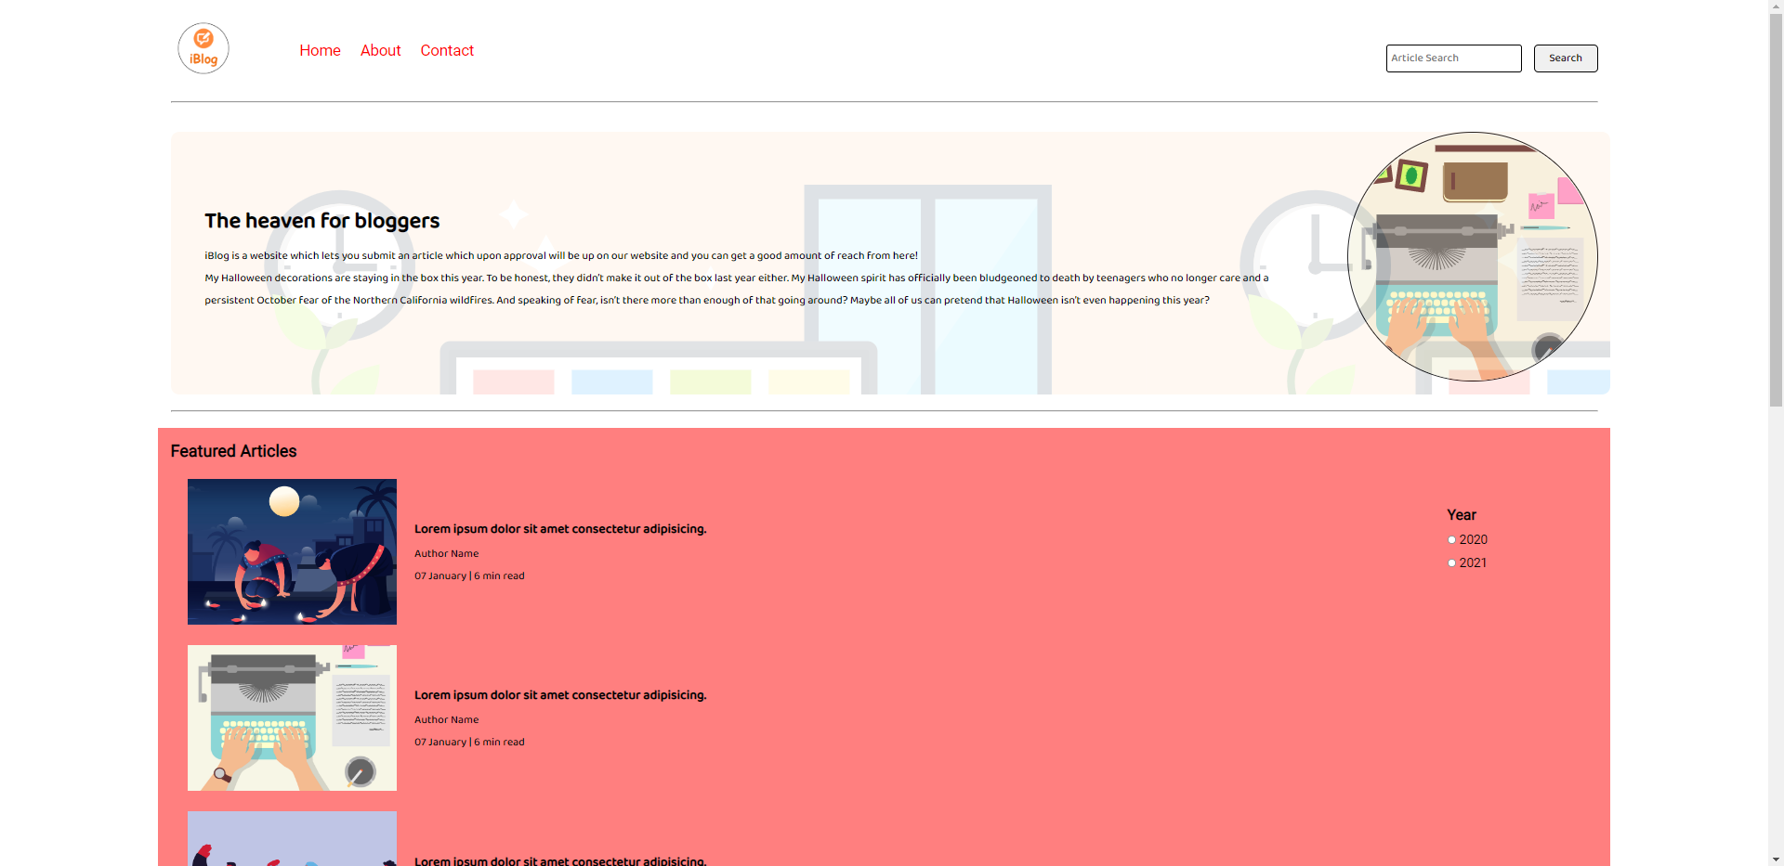**SYSTEM DESIGN**

**SOURCE CODE**

**For Index.html:**

**<!DOCTYPE html>**

**<html lang="en">**

**<head>**

**<meta charset="UTF-8">**

**<meta name="viewport" content="width=device-width, initial-scale=1.0">**

**<link rel="stylesheet" href="css/utils.css">**

**<link rel="stylesheet" href="css/style.css">**

**<link rel="stylesheet" href="css/mobile.css">**

**<title>iBlog - Heaven for bloggers</title>**

**</head>**

**<body>**

**<nav class="navigation max-width-1 m-auto">**

**<div class="nav-left">**

**<a href="/">**

**<span><img src="img/logo.png" width="94px" alt=""></span>**

**</a>**

**<ul>**

**<li><a href="/">Home</a></li>**

**<li><a href="/about.html">About</a></li>**

**<li><a href="/contact.html">Contact</a></li>**

**</ul>**

**</div>**

**<div class="nav-right">**

**<form action="/search.html" method="get">**

**<input class="form-input" type="text" name="query" placeholder="Article Search">**

**<button class="btn">Search</button>**

**</form>**

**</div>**

**</nav>**

**<div class="max-width-1 m-auto">**

**<hr>**

**</div>**

**<div class="m-auto content max-width-1 my-2">**

**<div class="content-left">**

**<h1>The heaven for bloggers</h1>**

**<p>iBlog is a website which lets you submit an article which upon approval will be up on our website and you**

**can get a good amount of reach from here!</p>**

**<p>My Halloween decorations are staying in the box this year. To be honest, they didn’t make it out of the**

**box last year either. My Halloween spirit has officially been bludgeoned to death by teenagers who no**

**longer care and a persistent October fear of the Northern California wildfires. And speaking of fear,**

**isn’t there more than enough of that going around? Maybe all of us can pretend that Halloween isn’t even**

**happening this year?</p>**

**</div>**

**<div class="content-right">**

**<img src="img/home.svg" alt="iBlog">**

**</div>**

**</div>**

**<div class="max-width-1 m-auto">**

**<hr>**

**</div>**

**<div class="home-articles max-width-1 m-auto font2">**

**<h2>Featured Articles</h2>**

**<div class="year-box adjust-year">**

**<div>**

**<h3>Year </h3>**

**</div>**

**<div>**

**<input type="radio" name="year" id=""> 2020**

**</div>**

**<div>**

**<input type="radio" name="year" id=""> 2021**

**</div>**

**</div>**

**<div class="home-article">**

**<div class="home-article-img">**

**<img src="img/3.png" alt="article">**

**</div>**

**<div class="home-article-content font1">**

**<a href="/blogpost.html">**

**<h3>Lorem ipsum dolor sit amet consectetur adipisicing.</h3>**

**</a>**

**<div>Author Name</div>**

**<span>07 January | 6 min read</span>**

**</div>**

**</div>**

**<div class="home-article">**

**<div class="home-article-img">**

**<img src="img/1.png" alt="article">**

**</div>**

**<div class="home-article-content font1">**

**<a href="/blogpost.html">**

**<h3>Lorem ipsum dolor sit amet consectetur adipisicing.</h3>**

**</a>**

**<div>Author Name</div>**

**<span>07 January | 6 min read</span>**

**</div>**

**</div>**

**<div class="home-article">**

**<div class="home-article-img">**

**<img src="img/2.png" alt="article">**

**</div>**

**<div class="home-article-content font1">**

**<a href="/blogpost.html">**

**<h3>Lorem ipsum dolor sit amet consectetur adipisicing.</h3>**

**</a>**

**<div>Author Name</div>**

**<span>07 January | 6 min read</span>**

**</div>**

**</div>**

**<div class="home-article">**

**<div class="home-article-img">**

**<img src="img/1.png" alt="article">**

**</div>**

**<div class="home-article-content font1">**

**<a href="/blogpost.html">**

**<h3>Lorem ipsum dolor sit amet consectetur adipisicing.</h3>**

**</a>**

**<div>Author Name</div>**

**<span>07 January | 6 min read</span>**

**</div>**

**</div>**

**<div class="home-article">**

**<div class="home-article-img">**

**<img src="img/11.svg" alt="article">**

**</div>**

**<div class="home-article-content font1">**

**<a href="/blogpost.html">**

**<h3>Lorem ipsum dolor sit amet consectetur adipisicing.</h3>**

**</a>**

**<div>Author Name</div>**

**<span>07 January | 6 min read</span>**

**</div>**

**</div>**

**<div class="home-article">**

**<div class="home-article-img">**

**<img src="img/3.png" alt="article">**

**</div>**

**<div class="home-article-content font1">**

**<a href="/blogpost.html">**

**<h3>Lorem ipsum dolor sit amet consectetur adipisicing.</h3>**

**</a>**

**<div>Author Name</div>**

**<span>07 January | 6 min read</span>**

**</div>**

**</div>**

**<div class="home-article">**

**<div class="home-article-img">**

**<img src="img/2.png" alt="article">**

**</div>**

**<div class="home-article-content font1">**

**<a href="/blogpost.html">**

**<h3>Lorem ipsum dolor sit amet consectetur adipisicing.</h3>**

**</a>**

**<div>Author Name</div>**

**<span>07 January | 6 min read</span>**

**</div>**

**</div>**

**<div class="home-article">**

**<div class="home-article-img">**

**<img src="img/11.svg" alt="article">**

**</div>**

**<div class="home-article-content font1">**

**<a href="/blogpost.html">**

**<h3>Lorem ipsum dolor sit amet consectetur adipisicing.</h3>**

**</a>**

**<div>Author Name</div>**

**<span>07 January | 6 min read</span>**

**</div>**

**</div>**

**</div>**

**<div class="footer">**

**<p>Copyright &copy; iBlog.com </p>**

**<a href="https://www.vecteezy.com/free-vector/typewriter">Vector Credits: Vecteezy</a>**

**</div>**

**</body>**

**</html>**

**For Blogpost.html**

**<!DOCTYPE html>**

**<html lang="en">**

**<head>**

**<meta charset="UTF-8">**

**<meta name="viewport" content="width=device-width, initial-scale=1.0">**

**<link rel="stylesheet" href="css/utils.css">**

**<link rel="stylesheet" href="css/style.css">**

**<link rel="stylesheet" href="css/blogpost.css">**

**<link rel="stylesheet" href="css/mobile.css">**

**<title>iBlog - Heaven for bloggers</title>**

**</head>**

**<body>**

**<nav class="navigation max-width-1 m-auto">**

**<div class="nav-left">**

**<a href="/">**

**<span><img src="img/logo.png" width="94px" alt=""></span>**

**</a>**

**<ul>**

**<li><a href="/">Home</a></li>**

**<li><a href="#">About</a></li>**

**<li><a href="/contact.html">Contact</a></li>**

**</ul>**

**</div>**

**<div class="nav-right">**

**<form action="/search.html" method="get">**

**<input class="form-input" type="text" name="query" placeholder="Article Search">**

**<button class="btn">Search</button>**

**</form>**

**</div>**

**</nav>**

**<div class="max-width-1 m-auto">**

**<hr>**

**</div>**

**<div class="post-img">**

**<img src="img/11.svg" alt="">**

**</div>**

**<div class="m-auto blog-post-content max-width-2 m-auto my-2">**

**<h1 class="font1">The heaven for bloggers</h1>**

**<div class="blogpost-meta">**

**<div class="author-info">**

**<div>**

**<b>**

**Author - Bill Gates (CEO Microtek)**

**</b>**

**</div>**

**<div>04 January. 6 min read</div>**

**</div>**

**<div class="social">**

**<svg width="29" height="29" class="hk">**

**<path**

**d="M22.05 7.54a4.47 4.47 0 0 0-3.3-1.46 4.53 4.53 0 0 0-4.53 4.53c0 .35.04.7.08 1.05A12.9 12.9 0 0 1 5 6.89a5.1 5.1 0 0 0-.65 2.26c.03 1.6.83 2.99 2.02 3.79a4.3 4.3 0 0 1-2.02-.57v.08a4.55 4.55 0 0 0 3.63 4.44c-.4.08-.8.13-1.21.16l-.81-.08a4.54 4.54 0 0 0 4.2 3.15 9.56 9.56 0 0 1-5.66 1.94l-1.05-.08c2 1.27 4.38 2.02 6.94 2.02 8.3 0 12.86-6.9 12.84-12.85.02-.24 0-.43 0-.65a8.68 8.68 0 0 0 2.26-2.34c-.82.38-1.7.62-2.6.72a4.37 4.37 0 0 0 1.95-2.51c-.84.53-1.81.9-2.83 1.13z">**

**</path>**

**</svg>**

**<svg style="background: black;**

**border-radius: 21px;" width="29" height="29" viewBox="0 0 29 29" fill="none" class="hk">**

**<path**

**d="M5 6.36C5 5.61 5.63 5 6.4 5h16.2c.77 0 1.4.61 1.4 1.36v16.28c0 .75-.63 1.36-1.4 1.36H6.4c-.77 0-1.4-.6-1.4-1.36V6.36z">**

**</path>**

**<path fill-rule="evenodd" clip-rule="evenodd"**

**d="M10.76 20.9v-8.57H7.89v8.58h2.87zm-1.44-9.75c1 0 1.63-.65 1.63-1.48-.02-.84-.62-1.48-1.6-1.48-.99 0-1.63.64-1.63 1.48 0 .83.62 1.48 1.59 1.48h.01zM12.35 20.9h2.87v-4.79c0-.25.02-.5.1-.7.2-.5.67-1.04 1.46-1.04 1.04 0 1.46.8 1.46 1.95v4.59h2.87v-4.92c0-2.64-1.42-3.87-3.3-3.87-1.55 0-2.23.86-2.61 1.45h.02v-1.24h-2.87c.04.8 0 8.58 0 8.58z"**

**fill="#fff"></path>**

**</svg>**

**<svg width="29" height="29" class="hk">**

**<path**

**d="M23.2 5H5.8a.8.8 0 0 0-.8.8V23.2c0 .44.35.8.8.8h9.3v-7.13h-2.38V13.9h2.38v-2.38c0-2.45 1.55-3.66 3.74-3.66 1.05 0 1.95.08 2.2.11v2.57h-1.5c-1.2 0-1.48.57-1.48 1.4v1.96h2.97l-.6 2.97h-2.37l.05 7.12h5.1a.8.8 0 0 0 .79-.8V5.8a.8.8 0 0 0-.8-.79">**

**</path>**

**</svg>**

**</div>**

**</div>**

**<p class="font1">In communications and information processing, code is a system of rules to convert**

**information—such as a letter, word, sound, image, or gesture—into another form, sometimes shortened or**

**secret, for communication through a communication channel or storage in a storage medium. An early example**

**is the invention of language, which enabled a person, through speech, to communicate what they thought, saw,**

**heard or felt to others. But speech limits the range of communication to the distance a voice can carry, and**

**limits the audience to those present when the speech is uttered . The invention of writing, which converted**

**spoken language into visual symbols, extended the range of communication across space and time.**

**The process of encoding converts information from a source into symbols for communication or storage.**

**Decoding is the reverse process, converting code symbols back into a form that the recipient understands,**

**such as English or/and Spanish.**

**One reason for coding is to enable communication in places where ordinary plain language, spoken or written,**

**is difficult or impossible. For example, semaphore, where the configuration of flags held by a signaler or**

**the arms of a semaphore tower encodes parts of the message, typically individual letters and numbers.**

**Another person standing a great distance away can interpret the flags and reproduce the words sent.</p>**

**<p class="font1">In communications and information processing, code is a system of rules to convert**

**information—such as a letter, word, sound, image, or gesture—into another form, sometimes shortened or**

**secret, for communication through a communication channel or storage in a storage medium. An early example**

**is the invention of language, which enabled a person, through speech, to communicate what they thought, saw,**

**heard or felt to others. But speech limits the range of communication to the distance a voice can carry, and**

**limits the audience to those present when the speech is uttered . The invention of writing, which converted**

**spoken language into visual symbols, extended the range of communication across space and time.**

**The process of encoding converts information from a source into symbols for communication or storage.**

**Decoding is the reverse process, converting code symbols back into a form that the recipient understands,**

**such as English or/and Spanish.**

**One reason for coding is to enable communication in places where ordinary plain language, spoken or written,**

**is difficult or impossible. For example, semaphore, where the configuration of flags held by a signaler or**

**the arms of a semaphore tower encodes parts of the message, typically individual letters and numbers.**

**Another person standing a great distance away can interpret the flags and reproduce the words sent.</p>**

**<p class="font1">In communications and information processing, code is a system of rules to convert**

**information—such as a letter, word, sound, image, or gesture—into another form, sometimes shortened or**

**secret, for communication through a communication channel or storage in a storage medium. An early example**

**is the invention of language, which enabled a person, through speech, to communicate what they thought, saw,**

**heard or felt to others. But speech limits the range of communication to the distance a voice can carry, and**

**limits the audience to those present when the speech is uttered . The invention of writing, which converted**

**spoken language into visual symbols, extended the range of communication across space and time.**

**Another person standing a great distance away can interpret the flags and reproduce the words sent.</p>**

**<p class="font1">In communications and information processing, code is a system of rules to convert**

**information—such as a letter, word, sound, image, or gesture—into another form, sometimes shortened or**

**secret, for communication through a communication channel or storage in a storage medium. An early example**

**is the invention of language, which enabled a person, through speech, to communicate what they thought, saw,**

**heard or felt to others. But speech limits the range of communication to the distance a voice can carry, and**

**limits the audience to those present when the speech is uttered . The invention of writing, which converted**

**spoken language into visual symbols, extended the range of communication across space and time.**

**The process of encoding converts information from a source into symbols for communication or storage.**

**Decoding is the reverse process, converting code symbols back into a form that the recipient understands,**

**such as English or/and Spanish.**

**.</p>**

**</div>**

**<div class="max-width-1 m-auto">**

**<hr>**

**</div>**

**<div class="home-articles max-width-1 m-auto font2">**

**<h2>People who read this also read</h2>**

**<div class="row">**

**<div class="home-article more-post">**

**<div class="home-article-img">**

**<img src="img/11.svg" alt="article">**

**</div>**

**<div class="home-article-content font1 center">**

**<a href="/blogpost.html">**

**<h3>Learn more about Machine Learning techniques in India by joining this channel</h3>**

**</a>**

**<div>Author Name</div>**

**<span>07 January | 6 min read</span>**

**</div>**

**</div>**

**<div class="home-article more-post">**

**<div class="home-article-img">**

**<img src="img/1.png" alt="article">**

**</div>**

**<div class="home-article-content font1 center">**

**<a href="/blogpost.html">**

**<h3>Learn more about Machine Learning techniques in India by joining this channel</h3>**

**</a>**

**<div>Author Name</div>**

**<span>07 January | 6 min read</span>**

**</div>**

**</div>**

**<div class="home-article more-post">**

**<div class="home-article-img">**

**<img src="img/2.png" alt="article">**

**</div>**

**<div class="home-article-content font1 center">**

**<a href="/blogpost.html">**

**<h3>Learn more about Machine Learning techniques in India by joining this channel</h3>**

**</a>**

**<div>Author Name</div>**

**<span>07 January | 6 min read</span>**

**</div>**

**</div>**

**</div>**

**</div>**

**<div class="footer">**

**<p>Copyright &copy; iBlog.com </p>**

**<a href="https://www.vecteezy.com/free-vector/typewriter">Vector Credits: Vecteezy</a>**

**</div>**

**</body>**

**</html>**

**For Search.html**

**<!DOCTYPE html>**

**<html lang="en">**

**<head>**

**<meta charset="UTF-8">**

**<meta name="viewport" content="width=device-width, initial-scale=1.0">**

**<link rel="stylesheet" href="css/utils.css">**

**<link rel="stylesheet" href="css/style.css">**

**<link rel="stylesheet" href="css/blogpost.css">**

**<link rel="stylesheet" href="css/mobile.css">**

**<title>iBlog - Heaven for bloggers</title>**

**</head>**

**<body>**

**<nav class="navigation max-width-1 m-auto">**

**<div class="nav-left">**

**<a href="/">**

**<span><img src="img/logo.png" width="94px" alt=""></span>**

**</a>**

**<ul>**

**<li><a href="/">Home</a></li>**

**<li><a href="#">About</a></li>**

**<li><a href="/contact.html">Contact</a></li>**

**</ul>**

**</div>**

**<div class="nav-right">**

**<form action="/search.html" method="get">**

**<input class="form-input" type="text" name="query" placeholder="Article Search">**

**<button class="btn">Search</button>**

**</form>**

**</div>**

**</nav>**

**<div class="max-width-1 m-auto">**

**<hr>**

**</div>**

**<div class="post-img">**

**<img src="img/11.svg" alt="">**

**</div>**

**<div class="m-auto blog-post-content max-width-2 m-auto my-2">**

**<h1 class="font1">The heaven for bloggers</h1>**

**<div class="blogpost-meta">**

**<div class="author-info">**

**<div>**

**<b>**

**Author - Bill Gates (CEO Microtek)**

**</b>**

**</div>**

**<div>04 January. 6 min read</div>**

**</div>**

**<div class="social">**

**<svg width="29" height="29" class="hk">**

**<path**

**d="M22.05 7.54a4.47 4.47 0 0 0-3.3-1.46 4.53 4.53 0 0 0-4.53 4.53c0 .35.04.7.08 1.05A12.9 12.9 0 0 1 5 6.89a5.1 5.1 0 0 0-.65 2.26c.03 1.6.83 2.99 2.02 3.79a4.3 4.3 0 0 1-2.02-.57v.08a4.55 4.55 0 0 0 3.63 4.44c-.4.08-.8.13-1.21.16l-.81-.08a4.54 4.54 0 0 0 4.2 3.15 9.56 9.56 0 0 1-5.66 1.94l-1.05-.08c2 1.27 4.38 2.02 6.94 2.02 8.3 0 12.86-6.9 12.84-12.85.02-.24 0-.43 0-.65a8.68 8.68 0 0 0 2.26-2.34c-.82.38-1.7.62-2.6.72a4.37 4.37 0 0 0 1.95-2.51c-.84.53-1.81.9-2.83 1.13z">**

**</path>**

**</svg>**

**<svg style="background: black;**

**border-radius: 21px;" width="29" height="29" viewBox="0 0 29 29" fill="none" class="hk">**

**<path**

**d="M5 6.36C5 5.61 5.63 5 6.4 5h16.2c.77 0 1.4.61 1.4 1.36v16.28c0 .75-.63 1.36-1.4 1.36H6.4c-.77 0-1.4-.6-1.4-1.36V6.36z">**

**</path>**

**<path fill-rule="evenodd" clip-rule="evenodd"**

**d="M10.76 20.9v-8.57H7.89v8.58h2.87zm-1.44-9.75c1 0 1.63-.65 1.63-1.48-.02-.84-.62-1.48-1.6-1.48-.99 0-1.63.64-1.63 1.48 0 .83.62 1.48 1.59 1.48h.01zM12.35 20.9h2.87v-4.79c0-.25.02-.5.1-.7.2-.5.67-1.04 1.46-1.04 1.04 0 1.46.8 1.46 1.95v4.59h2.87v-4.92c0-2.64-1.42-3.87-3.3-3.87-1.55 0-2.23.86-2.61 1.45h.02v-1.24h-2.87c.04.8 0 8.58 0 8.58z"**

**fill="#fff"></path>**

**</svg>**

**<svg width="29" height="29" class="hk">**

**<path**

**d="M23.2 5H5.8a.8.8 0 0 0-.8.8V23.2c0 .44.35.8.8.8h9.3v-7.13h-2.38V13.9h2.38v-2.38c0-2.45 1.55-3.66 3.74-3.66 1.05 0 1.95.08 2.2.11v2.57h-1.5c-1.2 0-1.48.57-1.48 1.4v1.96h2.97l-.6 2.97h-2.37l.05 7.12h5.1a.8.8 0 0 0 .79-.8V5.8a.8.8 0 0 0-.8-.79">**

**</path>**

**</svg>**

**</div>**

**</div>**

**<p class="font1">---BLOG CONTENT----.</p>**

**</div>**

**<div class="max-width-1 m-auto">**

**<hr>**

**</div>**

**<!DOCTYPE html>**

**<html lang="en">**

**<head>**

**<meta charset="UTF-8">**

**<meta name="viewport" content="width=device-width, initial-scale=1.0">**

**<link rel="stylesheet" href="css/utils.css">**

**<link rel="stylesheet" href="css/style.css">**

**<link rel="stylesheet" href="css/mobile.css">**

**<title>iBlog - Heaven for bloggers</title>**

**</head>**

**<body>**

**<nav class="navigation max-width-1 m-auto">**

**<div class="nav-left">**

**<a href="/">**

**<span><img src="img/logo.png" width="94px" alt=""></span>**

**</a>**

**<ul>**

**<li><a href="/">Home</a></li>**

**<li><a href="#">About</a></li>**

**<li><a href="/contact.html">Contact</a></li>**

**</ul>**

**</div>**

**<div class="nav-right">**

**<form action="/search.html" method="get">**

**<input class="form-input" type="text" name="query" placeholder="Article Search">**

**<button class="btn">Search</button>**

**</form>**

**</div>**

**</nav>**

**<div class="max-width-1 m-auto"><hr></div>**

**<div class="home-articles max-width-1 m-auto font2">**

**<h2>Search Results for Django (0.03 seconds)</h2>**

**<div class="year-box adjust-year">**

**<div>**

**<h3>Year </h3>**

**</div>**

**<div>**

**<input type="radio" name="year" id=""> 2020**

**</div>**

**<div>**

**<input type="radio" name="year" id=""> 2021**

**</div>**

**</div>**

**<div class="home-article">**

**<div class="home-article-img">**

**<img src="img/11.svg" alt="article">**

**</div>**

**<div class="home-article-content font1">**

**<a href="/blogpost.html"><h3>Lorem ipsum dolor sit amet consectetur adipisicing.</h3></a>**

**<span>Author Name</span>**

**<span>07 January | 6 min read</span>**

**</div>**

**</div>**

**<div class="home-article">**

**<div class="home-article-img">**

**<img src="img/11.svg" alt="article">**

**</div>**

**<div class="home-article-content font1">**

**<a href="/blogpost.html"><h3>Lorem ipsum dolor sit amet consectetur adipisicing.</h3></a>**

**<span>Author Name</span>**

**<span>07 January | 6 min read</span>**

**</div>**

**</div>**

**<div class="home-article">**

**<div class="home-article-img">**

**<img src="img/11.svg" alt="article">**

**</div>**

**<div class="home-article-content font1">**

**<a href="/blogpost.html"><h3>Lorem ipsum dolor sit amet consectetur adipisicing.</h3></a>**

**<span>Author Name</span>**

**<span>07 January | 6 min read</span>**

**</div>**

**</div>**

**<div class="home-article">**

**<div class="home-article-img">**

**<img src="img/home.svg" alt="article">**

**</div>**

**<div class="home-article-content font1">**

**<a href="/blogpost.html"><h3>Lorem ipsum dolor sit amet consectetur adipisicing.</h3></a>**

**<span>Author Name</span>**

**<span>07 January | 6 min read</span>**

**</div>**

**</div>**

**<div class="home-article">**

**<div class="home-article-img">**

**<img src="img/11.svg" alt="article">**

**</div>**

**<div class="home-article-content font1">**

**<a href="/blogpost.html"><h3>Lorem ipsum dolor sit amet consectetur adipisicing.</h3></a>**

**<span>Author Name</span>**

**<span>07 January | 6 min read</span>**

**</div>**

**</div>**

**<div class="home-article">**

**<div class="home-article-img">**

**<img src="img/11.svg" alt="article">**

**</div>**

**<div class="home-article-content font1">**

**<a href="/blogpost.html"><h3>Lorem ipsum dolor sit amet consectetur adipisicing.</h3></a>**

**<span>Author Name</span>**

**<span>07 January | 6 min read</span>**

**</div>**

**</div>**

**<div class="home-article">**

**<div class="home-article-img">**

**<img src="img/11.svg" alt="article">**

**</div>**

**<div class="home-article-content font1">**

**<a href="/blogpost.html"><h3>Lorem ipsum dolor sit amet consectetur adipisicing.</h3></a>**

**<span>Author Name</span>**

**<span>07 January | 6 min read</span>**

**</div>**

**</div>**

**<div class="home-article">**

**<div class="home-article-img">**

**<img src="img/11.svg" alt="article">**

**</div>**

**<div class="home-article-content font1">**

**<a href="/blogpost.html"><h3>Lorem ipsum dolor sit amet consectetur adipisicing.</h3></a>**

**<span>Author Name</span>**

**<span>07 January | 6 min read</span>**

**</div>**

**</div>**

**</div>**

**<div class="footer">**

**<p>Copyright &copy; iBlog.com </p>**

**<a href="https://www.vecteezy.com/free-vector/typewriter">Vector Credits: Vecteezy</a>**

**</div>**

**</body>**

**</html>**

**For About.html**

**<title>iBlog - Heaven for bloggers</title>**

**</head>**

**<body>**

**<nav class="navigation max-width-1 m-auto">**

**<div class="nav-left">**

**<a href="/">**

**<span><img src="img/logo.png" width="94px" alt=""></span>**

**</a>**

**<ul>**

**<li><a href="/">Home</a></li>**

**<li><a href="#">About</a></li>**

**<li><a href="/contact.html">Contact</a></li>**

**</ul>**

**</div>**

**<div class="nav-right">**

**<form action="/search.html" method="get">**

**<input class="form-input" type="text" name="query" placeholder="Article Search">**

**<button class="btn">Search</button>**

**</form>**

**</div>**

**</nav>**

**<div class="max-width-1 m-auto">**

**<hr>**

**</div>**

**<div class="m-auto content max-width-1 my-2">**

**<div class="content-left">**

**<h1>About Us</h1>**

**<p>iBlog is a website which lets you submit an article which upon approval will be up on our website and you**

**can get a good amount of reach from here!</p>**

**<p>----BLOG CONTENT----**

**</p>**

**</div>**

**<div class="content-right">**

**<img src="img/home.svg" alt="iBlog">**

**</div>**

**</div>**

**<div class="footer">**

**<p>Copyright &copy; iBlog.com </p>**

**<a href="https://www.vecteezy.com/free-vector/typewriter">Vector Credits: Vecteezy</a>**

**</div>**

**</body>**

**</html>**

**For Contact.html**

**<!DOCTYPE html>**

**<html lang="en">**

**<head>**

**<meta charset="UTF-8">**

**<meta name="viewport" content="width=device-width, initial-scale=1.0">**

**<link rel="stylesheet" href="css/utils.css">**

**<link rel="stylesheet" href="css/style.css">**

**<link rel="stylesheet" href="css/contact.css">**

**<link rel="stylesheet" href="css/mobile.css">**

**<title>iBlog - Heaven for bloggers</title>**

**</head>**

**<body>**

**<nav class="navigation max-width-1 m-auto">**

**<div class="nav-left">**

**<a href="/">**

**<span><img src="img/logo.png" width="94px" alt=""></span>**

**</a>**

**<ul>**

**<li><a href="/">Home</a></li>**

**<li><a href="#">About</a></li>**

**<li><a href="/contact.html">Contact</a></li>**

**</ul>**

**</div>**

**<div class="nav-right">**

**<form action="/search.html" method="get">**

**<input class="form-input" type="text" name="query" placeholder="Article Search">**

**<button class="btn">Search</button>**

**</form>**

**</div>**

**</nav>**

**<div class="max-width-1 m-auto">**

**<hr>**

**</div>**

**<div class="contact-content font1 max-width-1 m-auto">**

**<div class="max-width-1 m-auto mx-1">**

**<h2>Feel Free to Contact Us</h2>**

**<div class="contact-form">**

**<div class="form-box">**

**<input type="text" placeholder="Enter Your Name">**

**</div>**

**<div class="form-box">**

**<input type="text" placeholder="Enter Your Phone Number">**

**</div>**

**<div class="form-box">**

**<input type="text" placeholder="Enter Your Email Id">**

**</div>**

**<div class="form-box">**

**<textarea name="" id="" cols="30" rows="10" placeholder="How may we help you?"></textarea>**

**</div>**

**<div class="form-box">**

**<button class="btn">Submit</button>**

**</div>**

**</div>**

**</div>**

**</div>**

**<div class="footer">**

**<p>Copyright &copy; iBlog.com </p>**

**<a href="https://www.vecteezy.com/free-vector/typewriter">Vector Credits: Vecteezy</a>**

**</div>**

**</body>**

**</html>**

**CSS Code:**

**Index:**

**@import url("https://fonts.googleapis.com/css2?family=Roboto&display=swap");**

**@import url("https://fonts.googleapis.com/css2?family=Baloo+Bhaina+2:wght@500&display=swap");**

**:root {**

**--main-bg-color: #000000;**

**--font1: "Baloo Bhaina 2", cursive;**

**--font2: "Roboto", sans-serif;**

**}**

**.center{**

**text-align: center**

**}**

**.font1 {**

**font-family: var(--font1);**

**}**

**.font2 {**

**font-family: var(--font2);**

**}**

**.max-width-1 {**

**max-width: 80vw;**

**}**

**.max-width-2 {**

**max-width: 60vw;**

**}**

**.m-auto {**

**margin: auto;**

**}**

**.mx-1{**

**margin-left: 23px;**

**margin-right: 23px;**

**}**

**.my-2{**

**margin-top: 32px;**

**margin-bottom: 32px;**

**}**

**.btn {**

**padding: 0px 20px;**

**padding-top: 3px;**

**border: 2px solid black;**

**border-radius: 6px;**

**font-family: var(--font1);**

**font-size: 16px;**

**cursor: pointer;**

**transition: all 0.3s ease-in-out;**

**}**

**.btn:hover {**

**color: white;**

**background: var(--main-bg-color);**

**}**

**.form-input {**

**padding: 0px 5px;**

**padding-top: 3px;**

**font-size: 16px;**

**border: 2px solid black;**

**border-radius: 4px;**

**margin: 0 13px;**

**font-family: var(--font1);**

**}**

**.form-box input, textarea{**

**width: 52vw;**

**padding: 0px 6px;**

**margin: 7px 0;**

**font-size: 18px;**

**font-family: var(--font1);**

**border: 2px solid var(--main-bg-color);**

**border-radius: 5px;**

**}**

**BLOGPOST:**

**.post-img{**

**height: 404px;**

**overflow: hidden;**

**}**

**.post-img img{**

**width: 100%;**

**}**

**.blog-post-content{**

**/* background-color: rebeccapurple; */**

**}**

**.blog-post-content h1{**

**text-align: center;**

**}**

**.blog-post-content p{**

**font-size: 18px;**

**}**

**.row{**

**display: flex;**

**}**

**.more-post{**

**flex-direction: column;**

**align-items: center;**

**}**

**.blogpost-meta{**

**display: flex;**

**justify-content: space-between;**

**}**

**.author-info{**

**margin: 12px 0;**

**}**

**.author-info div{**

**padding: 4px 0px;**

**font-family: var(--font2);**

**}**

**.social{**

**padding-right: 53px;**

**align-self: center;**

**cursor: pointer;**

**}**

**CONTACT:**

**.contact-content{**

**height: 100vh;**

**margin-top: 32px;**

**padding: 9px;**

**position: relative;**

**overflow: hidden;**

**}**

**.contact-content::after {**

**content: "";**

**background-image: url("../img/11.svg");**

**position: absolute;**

**top:0;**

**width: 100%;**

**height: inherit;**

**opacity: 0.15;**

**border-radius: 12px;**

**z-index: -1;**

**}**

**OUTPUT SCREEN SHOTS**

1. Home page

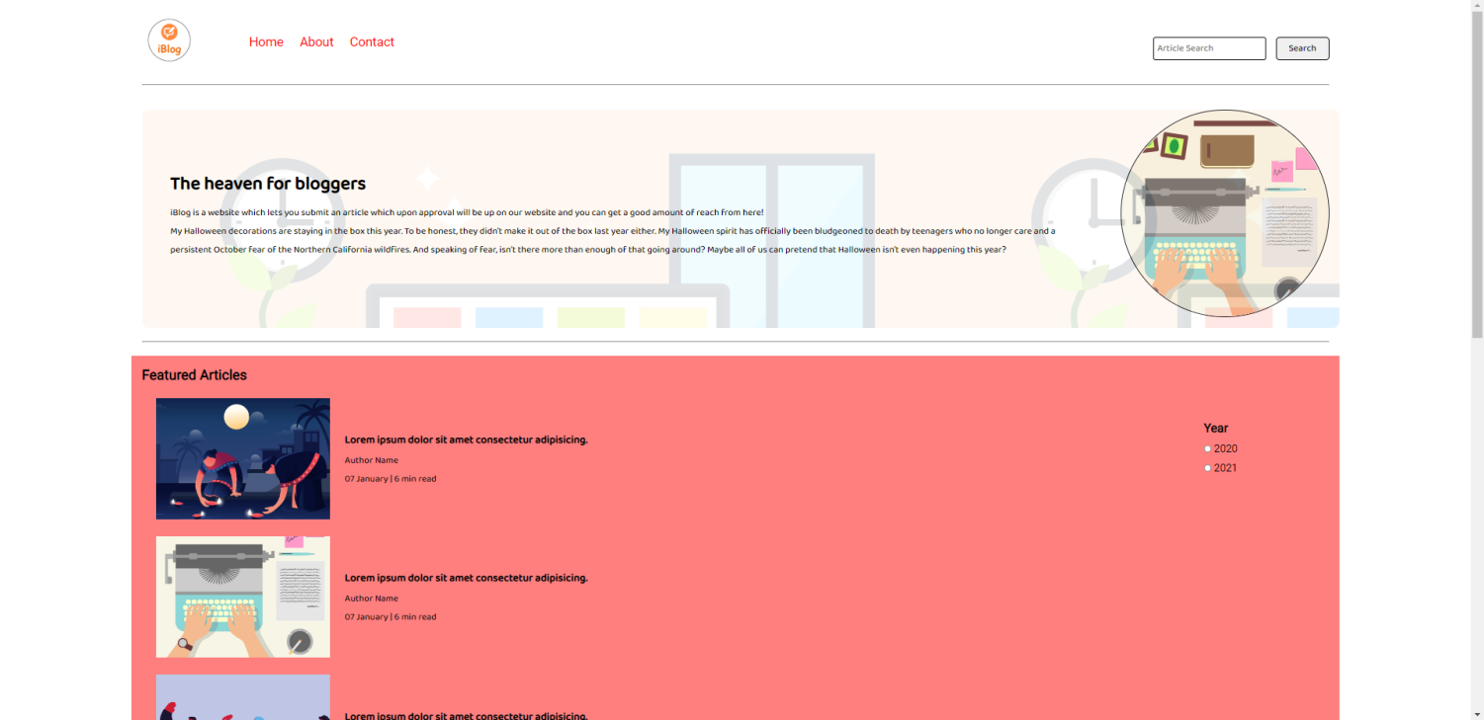

1. Blogpost page

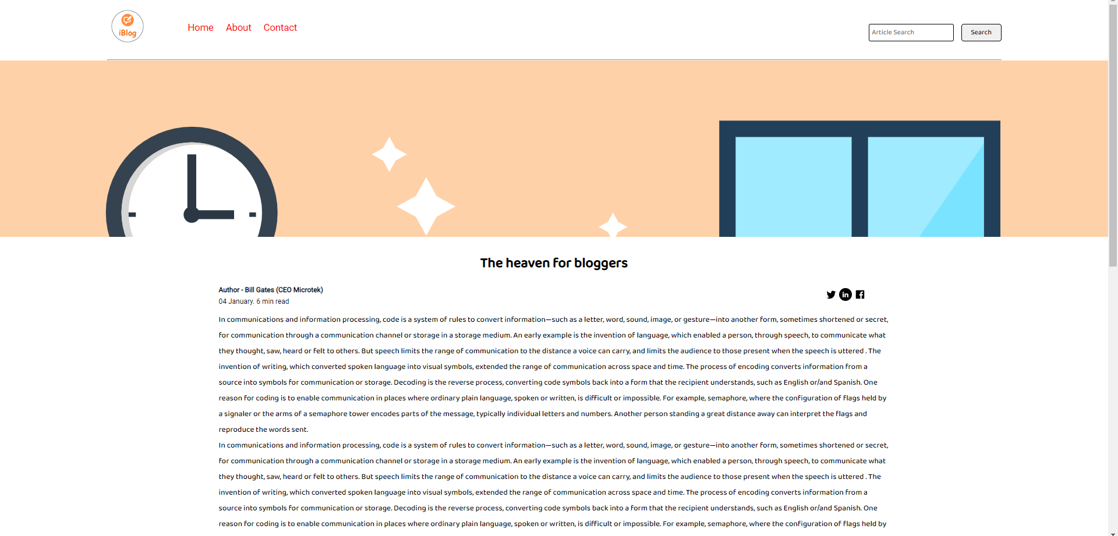

1. Search results page

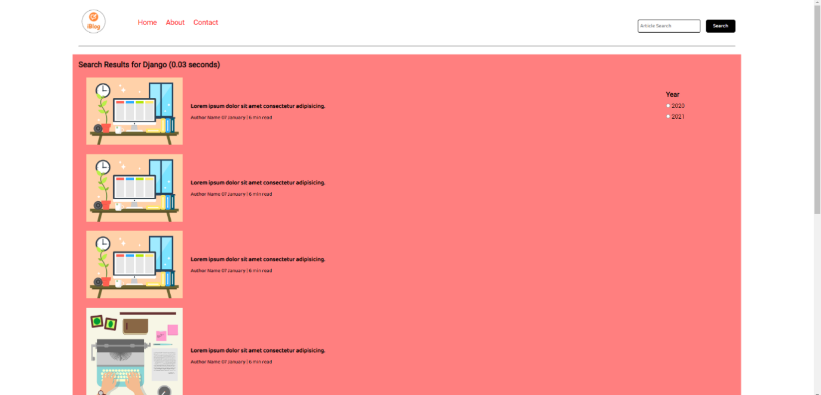

1. About page

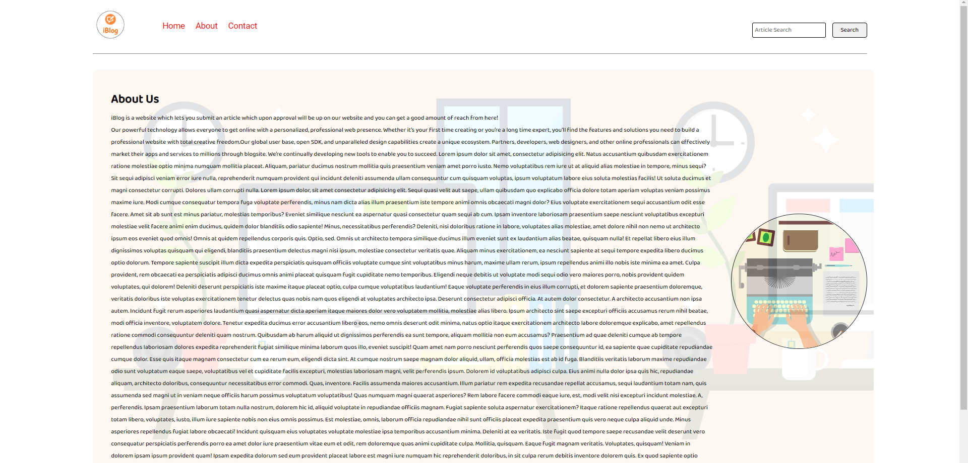

1. Contact page

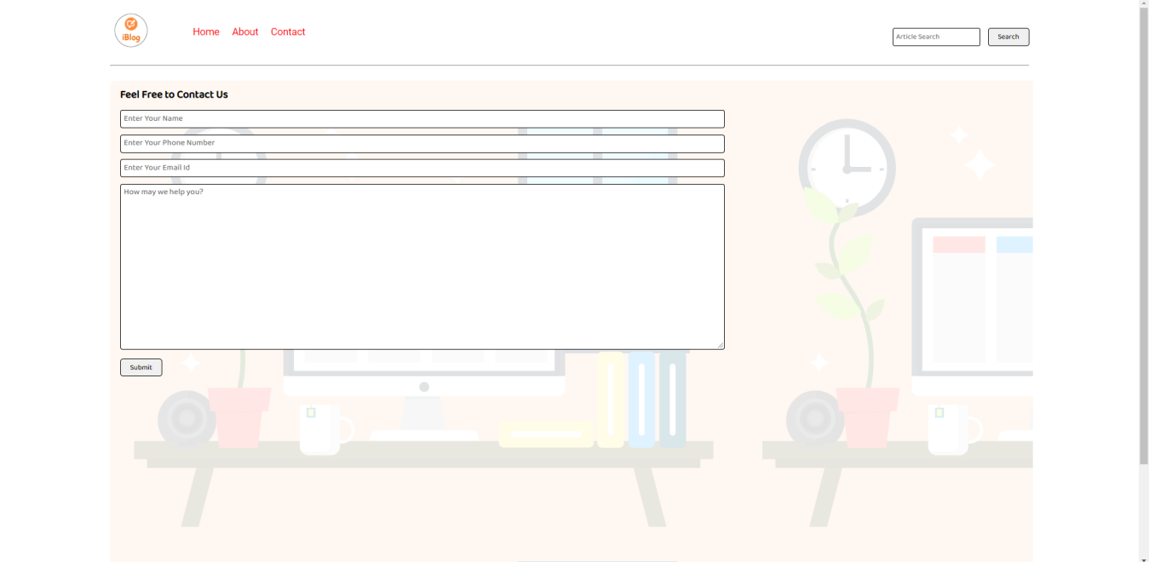

**CONCLUSION**

In summary, Blogsites are increasingly accurate and useful, and their benefits extend widely across the economy. While much has been accomplished in improving blogging buisness, there remains much room for improvement. The forecasting community is working closely with multiple stakeholders to ensure that bloggers and blog readers meet their specific needs. Simultaneously, they are developing new technologies and observational networks that can enhance an individuals skill and the value of their services to their users.

**REFERENCES:(websites/textbooks)**

**1.** [**https://www.geeksforgeeks.org/**](https://www.geeksforgeeks.org/)

**2.** [**https://fonts.google.com/specimen/Open+Sans**](https://fonts.google.com/specimen/Open+Sans)

**3.** [**https://www.youtube.com**](https://www.youtube.com)

**4.** [**https://www.vecteezy.com**](https://www.vecteezy.com)